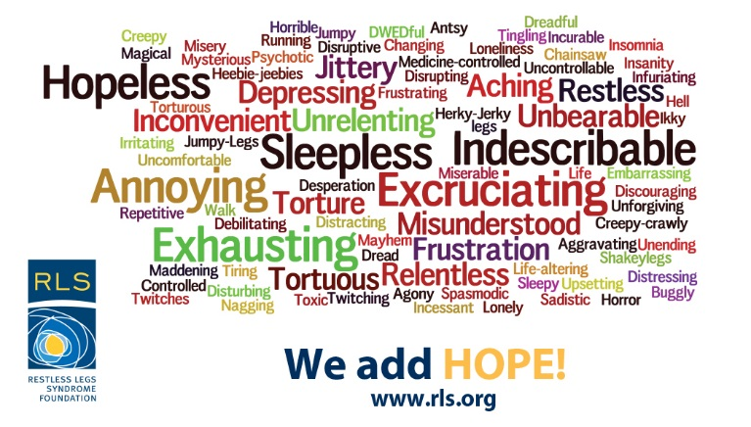

Join us to:

* **Receive the latest RLS Foundation guidance**
* **Network with others living with RLS**
* **Q&A with RLS medical expert, Mark Buchfuhrer, MD.**

**Speaker/Topic (Tentative):**

**Small Intestinal Bacterial Overgrowth (SIBO) and RLS: A New Connection?**

**When:** Sunday, October 22, 2017 | 1:00 – 3:30 pm

**Where:** Community Hospital of Long Beach

1720 Termino Avenue

Long Beach, CA 90804

For more information and to RSVP please contact Susan Schlichting

[susan@rlsgroups.org](mailto:susan@rlsgroups.org)

(310) 792-2952

**SoCal RLS Support Group**

Restless Legs Syndrome (RLS), also known as Willis-Ekbom disease, is a neurological disorder that causes an irresistible urge to move the legs, often accompanied by unusual or unpleasant sensations. Symptoms may also involve arms and other body parts.

Primary features of RLS may include these symptoms:

* Strong urge to move the legs/limbs. This need is often accompanied by uncomfortable sensations that might be described as creeping, itching, pulling, creepy-crawly, tugging or gnawing.
* Start or worsen when you are resting.
* Improve when you move your legs or other affected body parts.
* Worsen in the evening, especially when you are lying down.
* Cannot solely be attributed to a medical or behavioral disorder (e.g., arthritis, leg cramps, vein disorders, habitual foot tapping.)
* Cause significant stress on your relationships, work, family, education or other area of life by impacting your sleep, energy/vitality, daily activities or mood.
  + - Information from the RLS Foundation ‘Causes’ brochure

Visit the RLS Foundation at www.rls.org

Restless Legs Syndrome